# First PowerBI App

Download our data *Financial Sample.xlsx* from moodle and save it to a specific folder set aside for Data Visualisation.

Open the file in excel and have a look at the data.

**Note:** the data columns are highlighted as a table – powerbi will only detect data that is in a ***table***

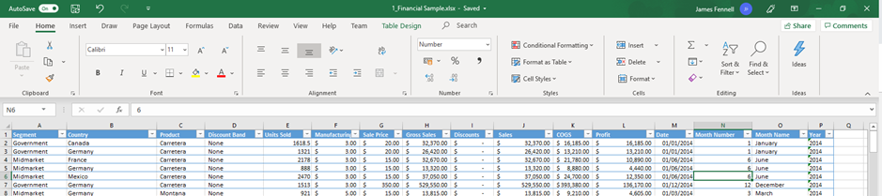

Note the headings in the columns and the types of data under each heading,

Qunatitative vs Qualitative, dates, strings, types of numbers etc.

## Launch powerBI Desktop

Select get data

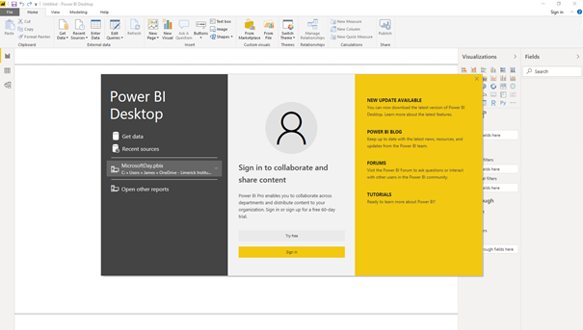

We should get to the PowerBI Application

Close the get data window and look at the home environment

## Home Environment

In Power BI Desktop home environment, you'll begin to build reports in the Report view. You'll be working in five main areas:

1. **Ribbon**

Displays common tasks that are associated with reports and visualizations

1. **Report view (canvas)**

Where visualizations are created and arranged

switch between Report, Data, and Model views by selecting the icons in the left column

1. **Pages tab**

Located along the bottom of the page, this area is where you would select or add a report page.

1. **Visualizations pane**

Where you can change visualizations, customize colours or axes, apply filters, drag fields, and more.

1. **Fields pane**

Where query elements and filters can be dragged onto the Report view or dragged to the Filters area of the Visualizations pane

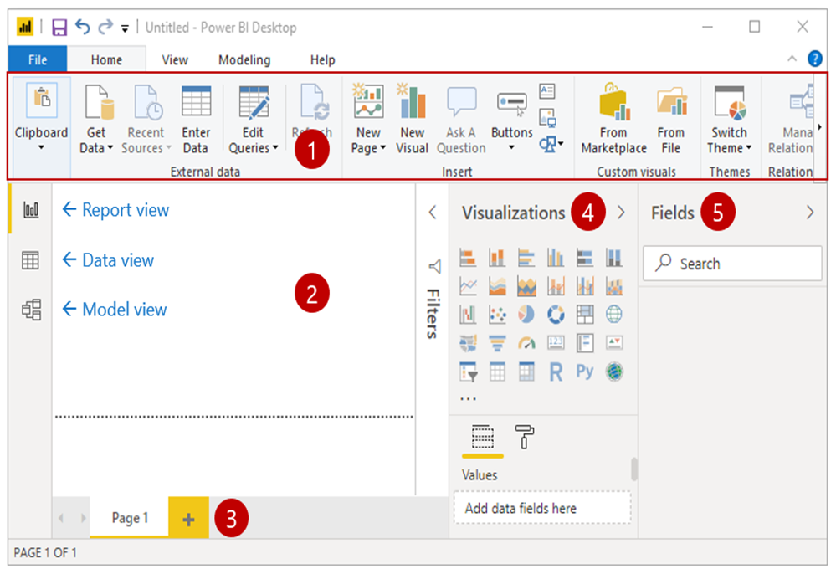

## Import Data

Select

1

1 file -> 2 Get Data -> 3 Excel

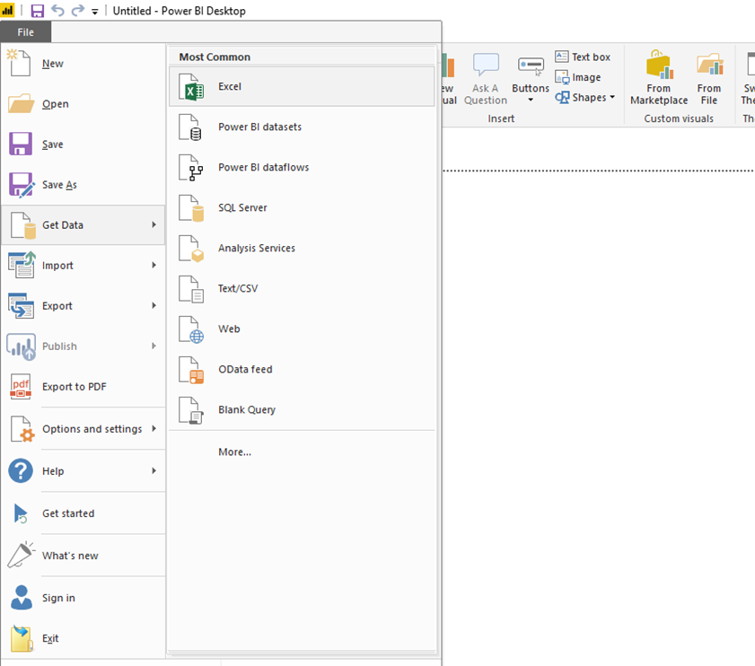

3

2

Import the *Financial Sample.xlsx* data from the file you saved into PowerBI

## Load the Data

After connecting to excel and loading you should see the data in a “Navigator” window

Click on financials to get a summary of the data in the excel file

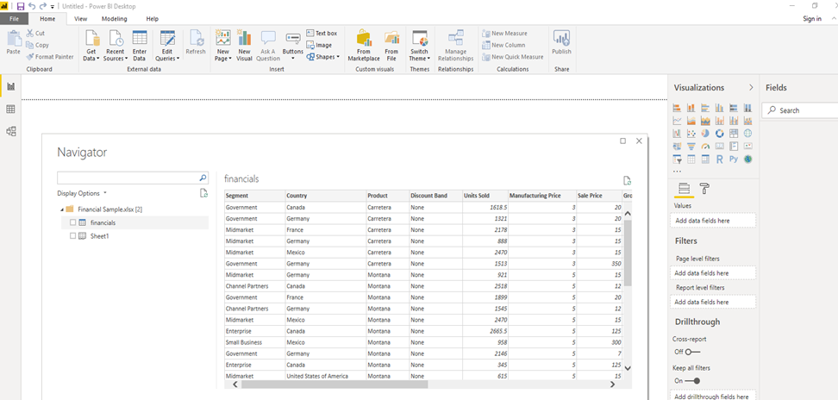

If the data is not in a standard format or if there are unusual entries here is where you can “clean” the data.

This is not necessary in this case – the data is well formulated and clean.

Visualise the Data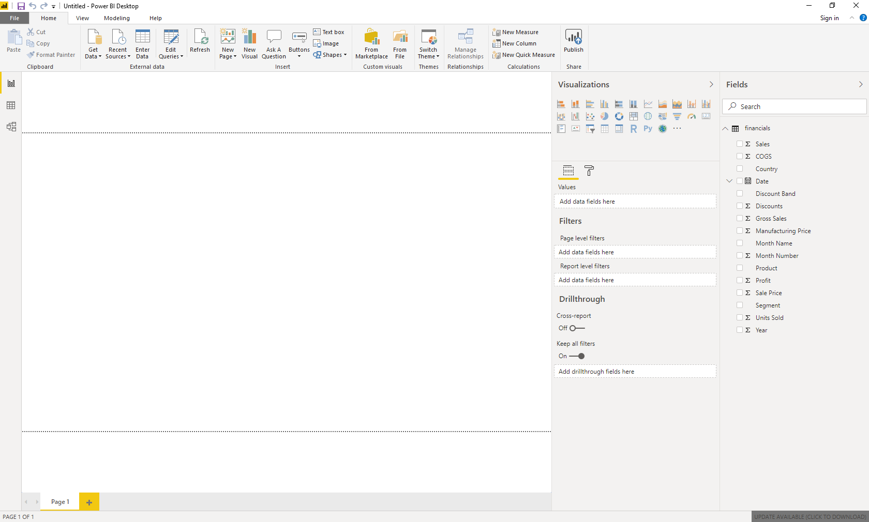

Once loaded all the fields become available in the “Fields” panel

Now we can build “tiles” by simply dragging and dropping the fields onto the canvas

We edit the style of visualisation using the “Visualisation” panel

We will look at Sales, Segment and Product

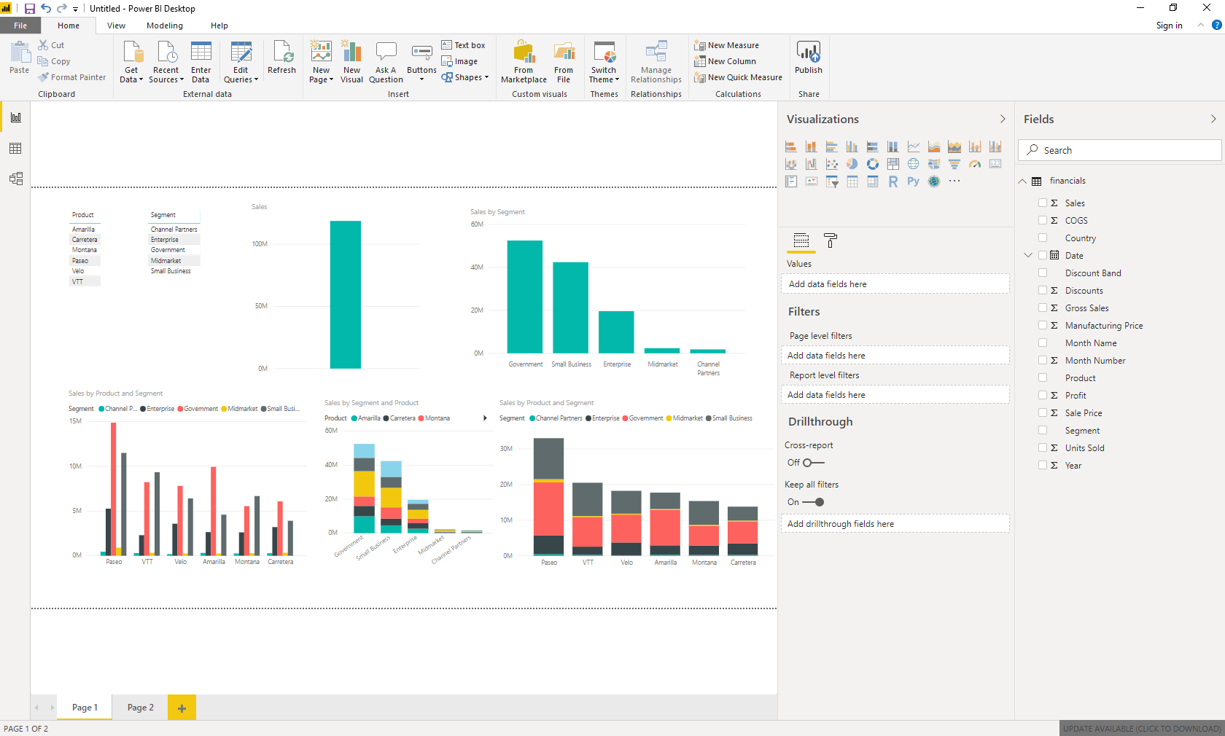

|  |  |  |
| --- | --- | --- |
| 1 &2 | 1 = Product, 2= Segment | Table |
| 3 | Sales | Bar Chart |
| 4 | Sales x Segment | Bar Chart |
| 5 | Sales x Product x Segment | Cluster Stacked Bar Chart |
| 6 | Sales x Segment x Product | Stacked Bar Chart |
| 7 | Sales x Product x Segment | Stacked Bar Chart |

## Map Visualisation

Another interesting visualisation is the Map

We select the Country and Sales fields

PowerBI automatically picks up that a map visualisation is one of the appropriate types and displays the sales for each country in that visualisation.

